|  |  |  |  |  |  |
| --- | --- | --- | --- | --- | --- |
| Date | 1-Dec-22 | | | Tester Name | Andrew McLaughlin |
| Environment | Penfax - Test | | | Login used |  |
| Operating System | Select OS | Version: | Update: | | |
| Software Used | Select Software | Version: | Update: | | |
| Select Software | Version: | Update: | | |
| Release version | 22.4.1 | | | | |
| Title | Overpayment to member – Non-MEPP | | | | |
| Test Type | Regression | | | | |
| Test Scenario | Overpayment to member – Non-MEPP | | | | |
|  |  | | | | |
| Expected Results |  | | | | |
| Pass/Fail | Pass | | | JIRA# | N/A |

Describe your steps with screenshots:

Members are entitled to payment up until the end of the month they pass away. When PEBA is not notified until after payments have been processed, overpayments are created.

Member has received pension up until their Sep 2022 payment 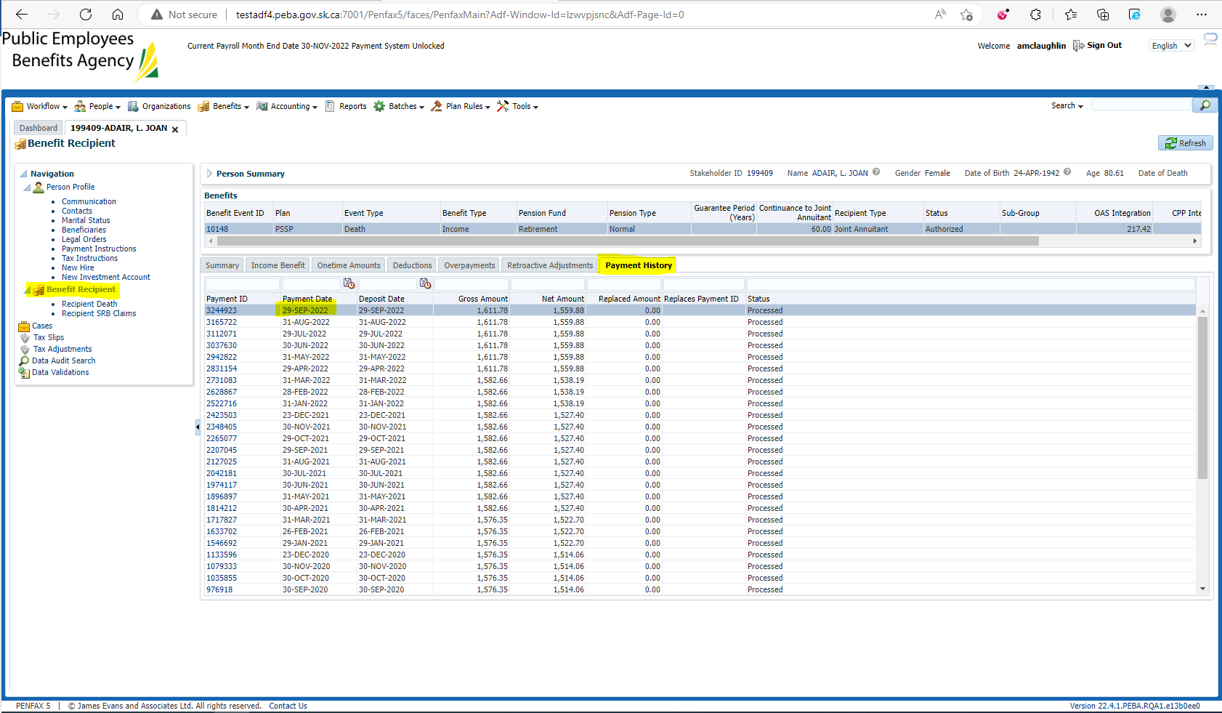

Add a Death date in the past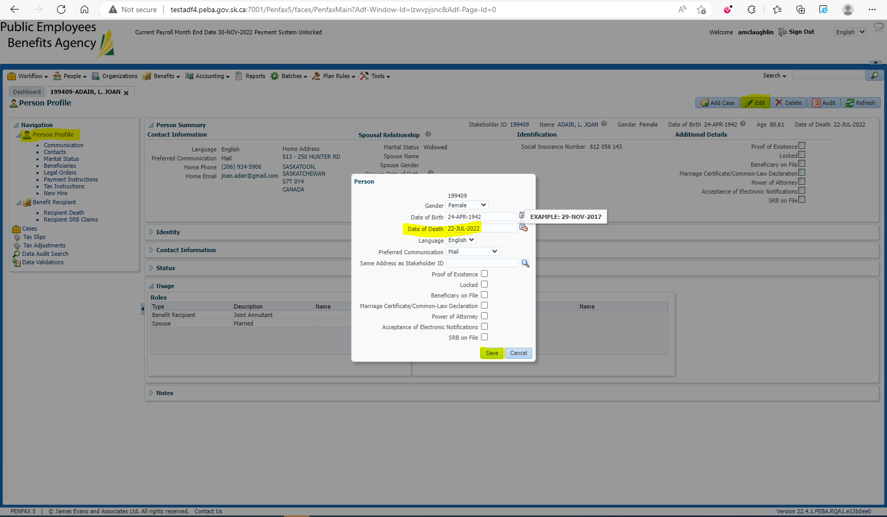

Under Payment History > Payment ID > Cancel the payments the member is not entitled to 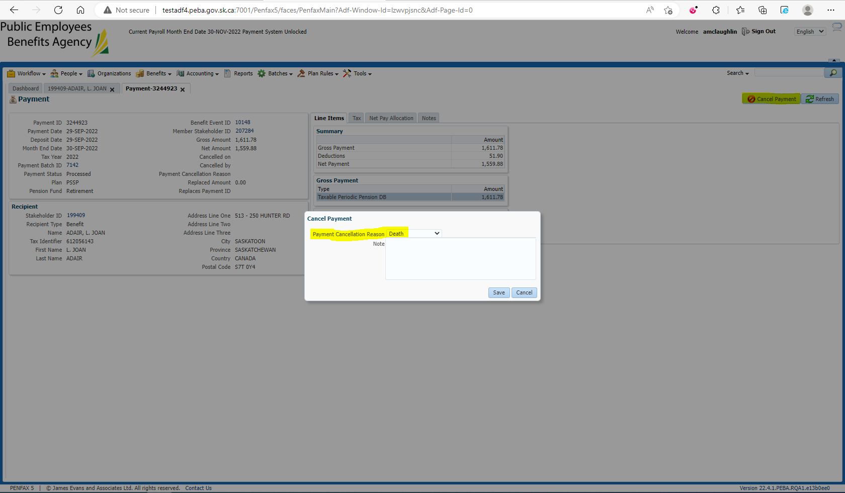

Verify under Payment History that they are now Cancelled – Pending Recovery 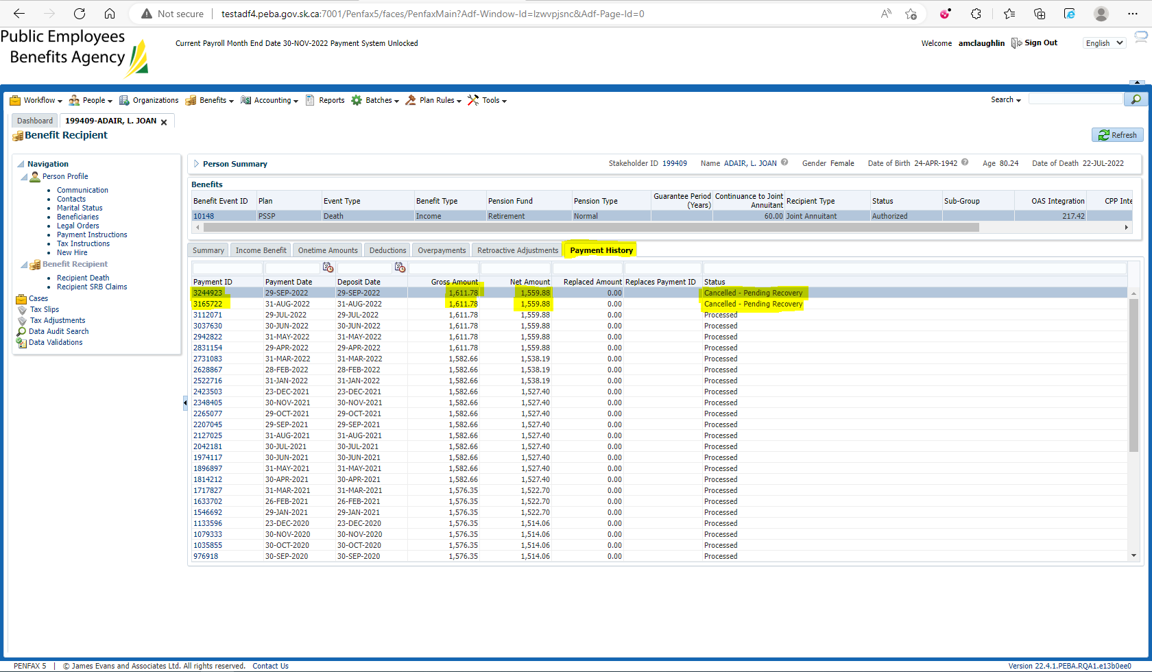

In the Overpayments tab, there is now matching items for the same gross amount divided into the same Net Amount/Tax 